Python Pillow - Using Image Module

[Previous Page](https://www.tutorialspoint.com/python_pillow/python_pillow_environment_setup.htm)

[Next Page](https://www.tutorialspoint.com/python_pillow/python_pillow_working_with_images.htm)

To display the image, pillow library is using an image class within it. The image module inside pillow package contains some important inbuilt functions like, load images or create new images, etc.

Opening, rotating and displaying an image

To load the image, we simply import the image module from the pillow and call the **Image.open()**, passing the image filename.

Instead of calling the Pillow module, we will call the PIL module as to make it backward compatible with an older module called Python Imaging Library (PIL). That’s why our code starts with **“from PIL import Image”** instead of **“from Pillow import Image”**.

Next, we’re going to load the image by calling the **Image.open() function**, which returns a value of the Image object data type. Any modification we make to the image object can be saved to an image file with the **save()** method. The image object we received using **Image.open()**, later can be used to resize, crop, draw or other image manipulation method calls on this Image object.

Example

Following example demonstrates the rotation of an image using python pillow −

from PIL import Image

#Open image using Image module

im = Image.open("images/cuba.jpg")

#Show actual Image

im.show()

#Show rotated Image

im = im.rotate(45)

im.show()

Output

If you save the above program as Example.py and execute, it displays the original and rotated images using standard PNG display utility, as follows −

**Actual image**

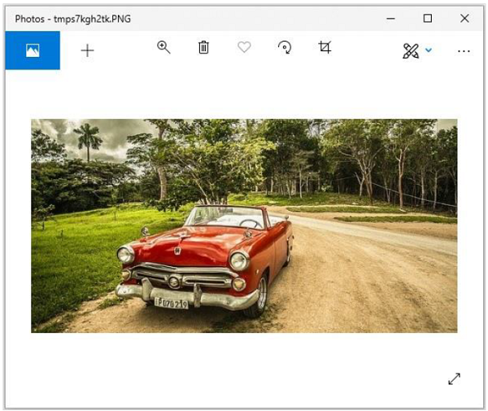

**Rotated image (45 degrees)**

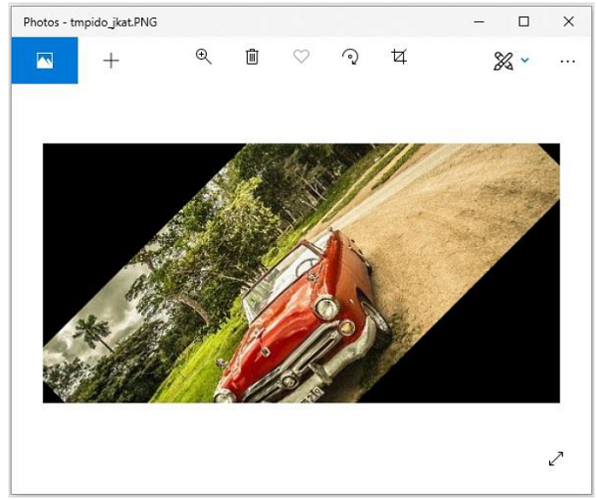

Attributes of Image Module

The instance of the Image class has some attributes. Let’s try to understand few of them by example −

Image.filename

This function is used to get the file name or the path of the image.

>>>image = Image.open('beach1.jpg')

>>> image.filename

'beach1.jpg'

Image.format

This function returns file format of the image file like ‘JPEG’, ‘BMP’, ‘PNG’, etc.

>>> image = Image.open('beach1.jpg')

>>>

>>> image.format

'JPEG'

Image.mode

It is used to get the pixel format used by the image. Typical values are “1”, “L”, “RGB” or “CMYK”.

>>> image.mode

'RGB'

Image.size

It returns the tuple consist of height & weight of the image.

>>> image.size

(1280, 721)

Image.width

It returns only the width of the image.

>>> image.width

1280

Image.height

It returns only the height of the image.

>>> image.height

721

Image.info

It returns a dictionary holding data associated with the image.

>>> image.info

{'jfif': 257, 'jfif_version': (1, 1), 'dpi': (300, 300), 'jfif_unit': 1, 'jfif_density': (300, 300), 'exif': b"Exif\x00\x00MM\x00*\x00\x00\x00

....

....

\xeb\x00\x00'\x10\x00\x00\xd7\xb3\x00\x00\x03\xe8"}

Image.palette

It returns the colour palette table, if any.

>>> image.palette

**Output above** − None